UML. The difference between black box and white box in the component diagram
Ask Question
A black box is, as the name says, black inside. You can't see what is inside. In contrast a white box shows anything inside. It depends on the use case which one to prefer.
You often get a black box when you buy a product from a company. They hide what exactly is inside and how they made it.
Open source in contrast is a white box.
Is it only the difference between the black box and the white one that only interfaces can be specified for the first, while for the second we can display the Internal structure?

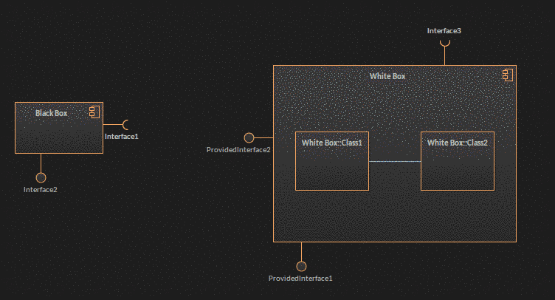
On the diagram showed the vision of the differences in the boxes. Is
itcorrect? 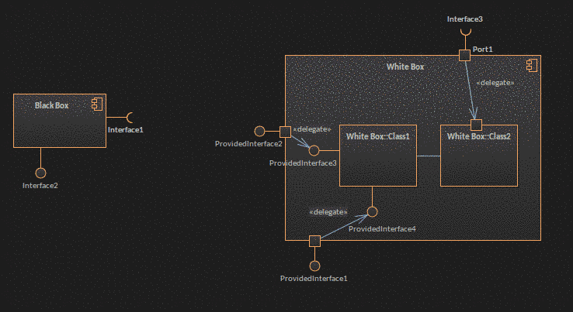
uml
- The first diagram shows that Class1 and Class2 realize Component WhiteBox. The second shows Connectors inside WhiteBox. This is only possible in a Composite Structure Diagram, which can be shown in a compartment, but needs to have a line separating it from the name. The parts then should have a leading colon, to separate the role (empty here) and the type. Finally a connector is only possible between parts or ports. Therefore, Class1 needs to have two ports. The connector may be shown connected to the Interface, but in fact it will be connected to the port. It doesn’t have arrows or stereotype.

Every component can be drawn either as a black box or as a white box. If you draw a component as a black box, you don't show its internals, only its interface(s). If you draw the same component as a white box, you do show its internals.
Both diagrams are valid UML diagrams.
The more details you give the "whiter" it becomes. On the other hand you never give all details just like you never model all aspects of a model - that's why we call it a model.

12.7. Black-Box and White-Box Component Views
There are two views of components in UML: a black-box view and a white-box view. The black-box view shows how a component looks from the outside, including its required interfaces, its provided interfaces, and how it relates to other components. A black-box view specifies nothing about the internal implementation of a component. The white-box view, on the other hand, shows which classes, interfaces, and other components help a component achieve its functionality.
In this chapter, you've seen both black-box and white-box views. So, what's the difference in practical terms? A white-box view is one that shows parts inside a component, whereas a black-box view doesn't, as shown in Figure 12-20.

Figure 12-20. Black-box component views are useful for showing the big picture of the components in your system, whereas white-box views focus on the inner workings of a component
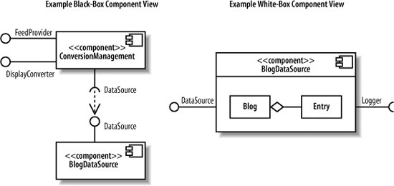

When modeling your system, it's best to use black-box views to focus on
- large-scale architectural concerns.
- Black-box views are good at showing the key components in your system and how they're connected.
Best to use White-box views to focus on, on the other hand, are useful for showing how a component achieves its functionality through the classes it uses.
Black-box views usually contain more than one component, whereas in a white-box view, it's common to focus on the contents of one component.
https://www.youtube.com/watch?v=blxNIP8XuCg

